Instrumentation & Control

LAB 1

Task 1 –What is ArduinoRead the introduction to Arduino from their official website. This website is a great resource for all things related to Arduino. https://www.arduino.cc/en/guide

Task 2 –Arduino development environmentInstalling the Integrated development environment (IDE)if is not already installed locally.Go to the website and download the IDE.Follow the <https://www.arduino.cc/en/Guide>

Task 3 –Plugin the board https://www.tutorialspoint.com/arduino/arduino_installation.htm

Task 4 –Build your first program Build run the following example program and you will have a blinking LED on your Arduino board.

See Images Below.

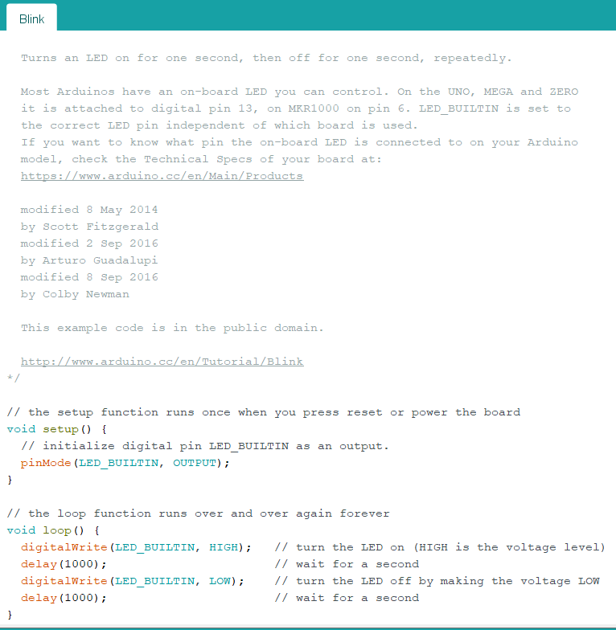

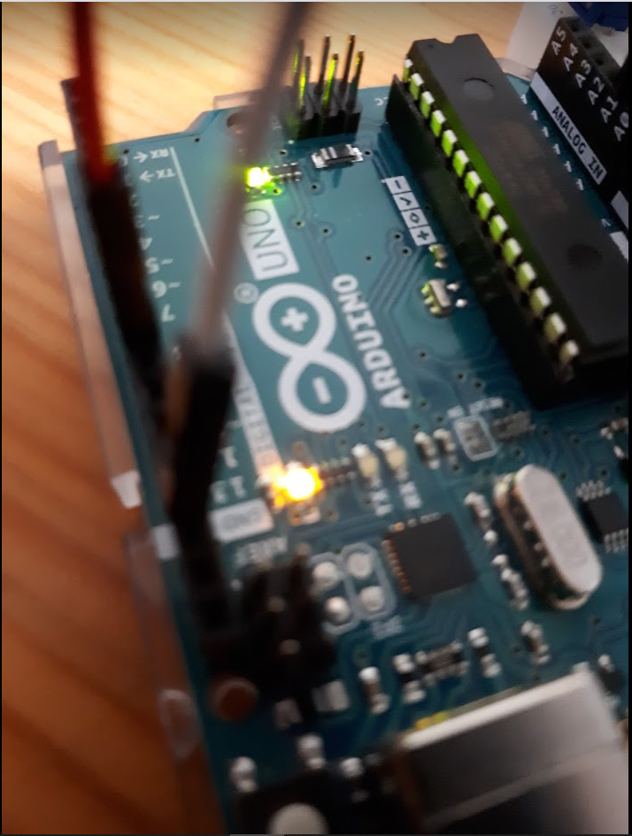

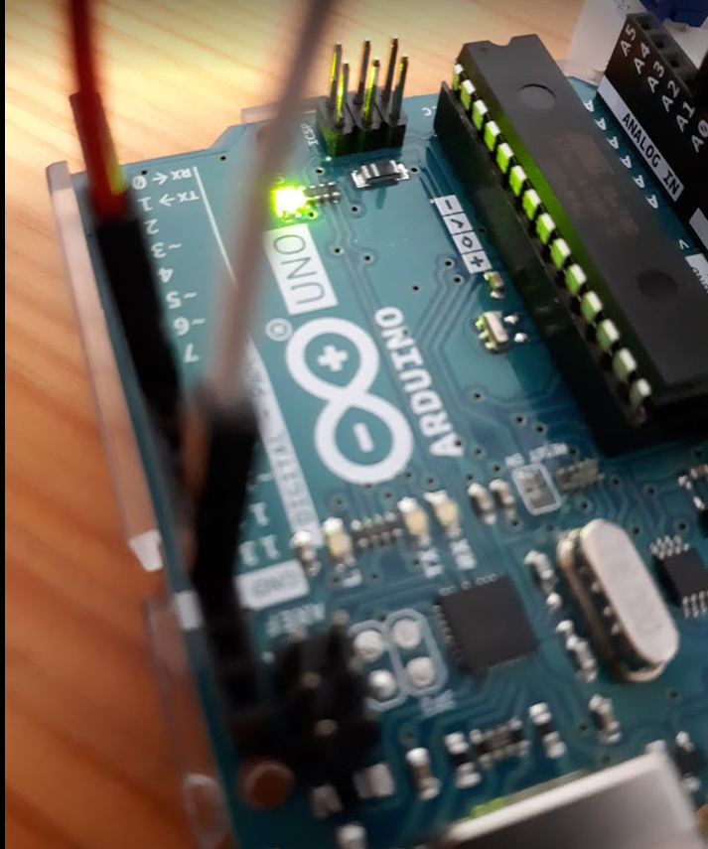

Task 5:Open the Arduino IDE software on your computer.You need to tell the Arduino whether it is an Input or an Output and which Pin you are going to use .In the program below I used pin 9.Then run your Program. See Images Below.

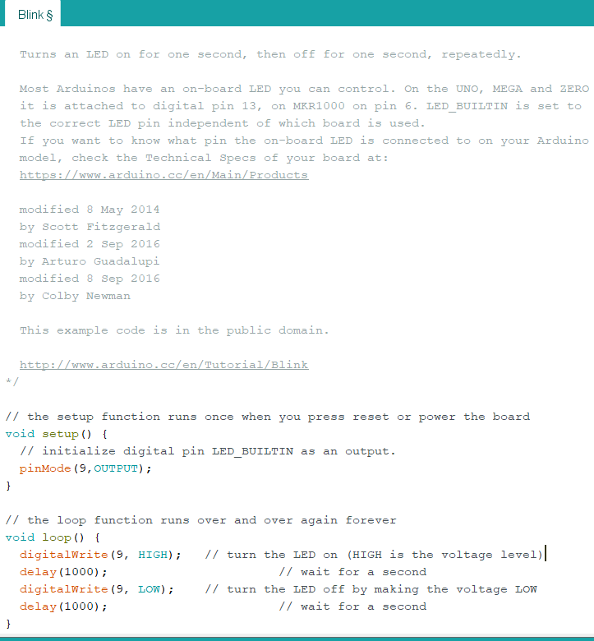

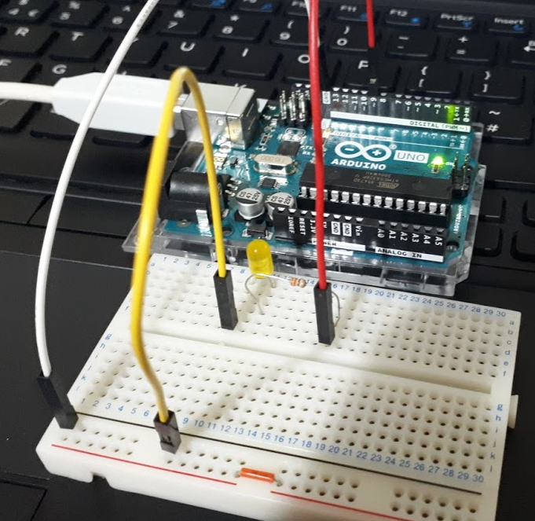

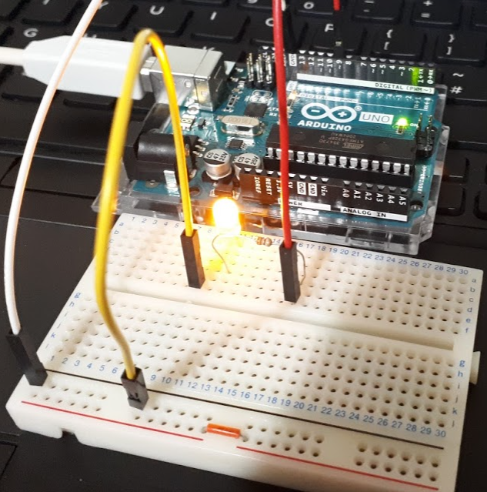

Task 6:Open the Arduino IDE software on your computer.Go to the program Fade open the program below I used pin 9.Then run your Program.You should see your LED on the breadboard go from fully bright all the way too off see images below:

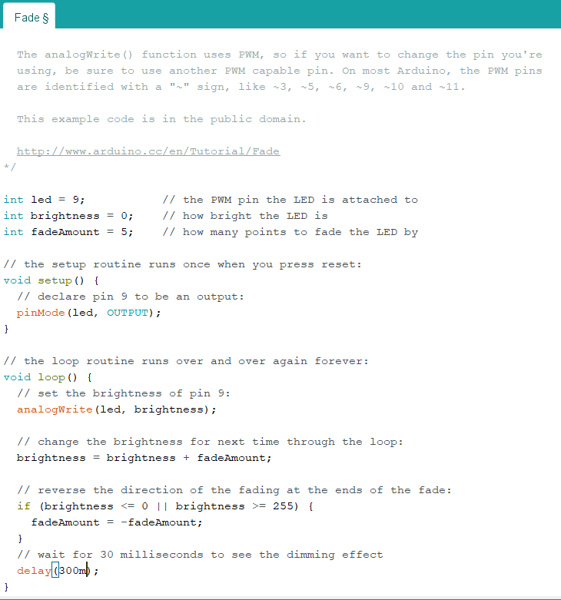

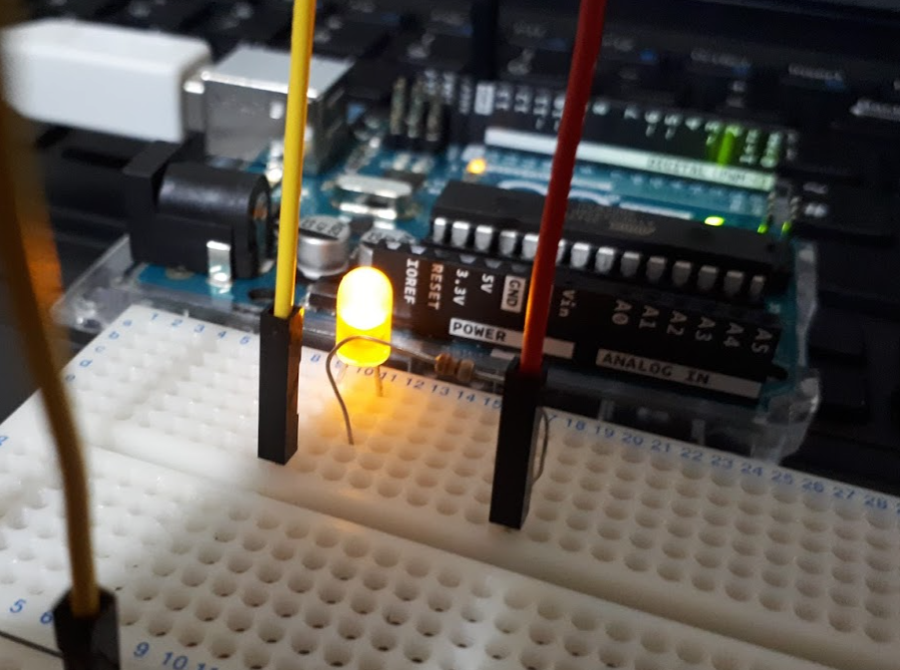

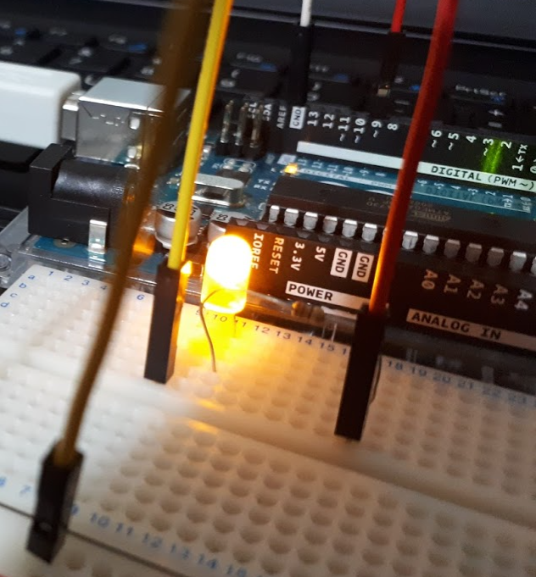

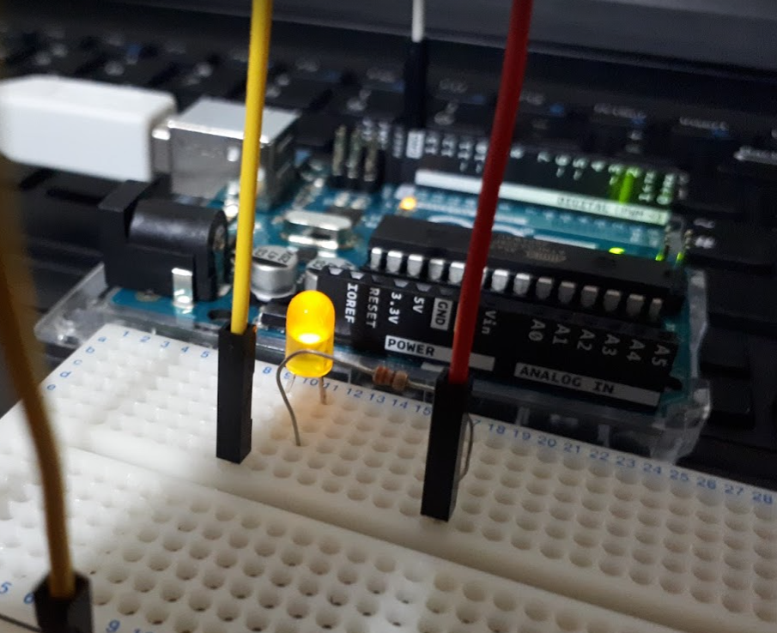

Task 7: Expand on task 5,6 add two extra LEDs.

LED bar graph

Turns on a series of LEDs based on the value of an analog sensor.

This is a simple way to make a bar graph display.

Though this graph uses 2LEDs, you can use any number by

changing the LED count and the pins in the array.

This method can be used to control any series of digital

outputs that depends on an analog input.

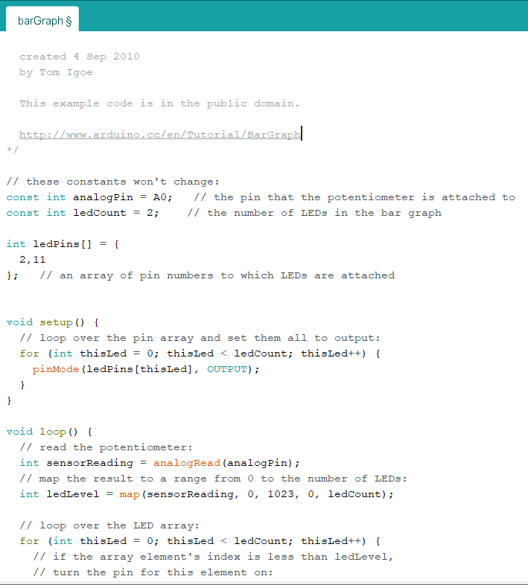

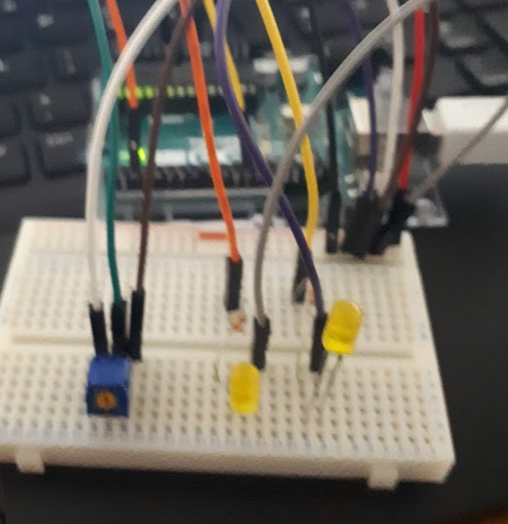

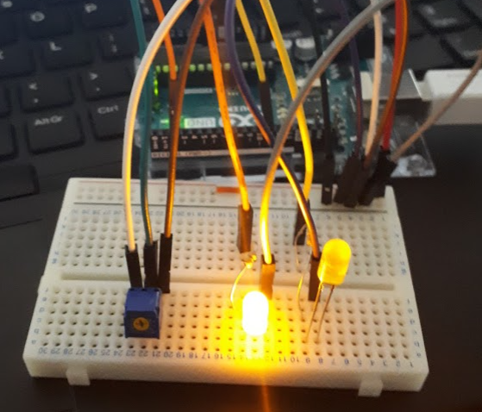

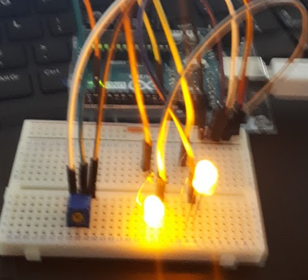

Task 8: This example will show you how to read an analog input on analog pin 0. The input is converted from analogRead() into voltage, and printed out to the serial monitor of the Arduino Software see Images below.

